**DESIGN AND IMPLEMENTATION OF A MOBILE APPLICATION THAT CONNECTS BUYERS TO NEARBY SELLERS (FINDNEARME)**

**PROJECT SUBMITTED IN PARTIAL FULFILLMENT OF THE REQUIREMENT**

**FOR THE DEGREE OF**

**B.SC.**

**IN**

**COMPUTER SCIENCE (SOFTWARE ENGINEERING)**

**BY**

**ALIYU, HADIZA**

**TO**

**THE DEPARTMENT OF COMPUTER SCIENCE**

**BAZE UNIVERSITY, ABUJA**

**JANUARY, 2025**

**DECLARATION**

I hereby declare that the project work entitled “**Design and implementation of a mobile application that connects buyers to nearby sellers”** is a record of an original work done by Aliyu Hadiza under the guidance of Mr. Usman Bello Abubakar. This project is submitted in the partial fulfillment of the requirements of the award of the degree of B.Sc. in Software Engineering to the Department of Computer Science, Baze University Abuja, Nigeria. The results embodied in this project have not been submitted to any other university or institution for the award of any degree.

_________________________ _____________________

Aliyu HadizaDate

BU/22A/IT/6545

**APPROVED BY**

**_____________________**

**Head of Department,**

Department of Computer Science

**CERTIFICATION**

This is to certify that this project “**FindNearMe”** submitted by Aliyu Hadiza, in partial fulfillment of the requirements for the award of the degree of B.Sc. Software Engineering to the department of Computer Science, Baze University Abuja, Nigeria, is an authentic work carried out by the candidate under my guidance. The matter embodied in this project is original and has not been submitted for the award of any other degree.

**_____________________ ______________________________**

Date Dr Usman Bello Abubakar

**APPROVAL**

This is to approve that this project entitled “**FindNearMe”** submitted by Aliyu Hadiza has been examined and is hereby approved as a credible work in partial fulfillment of the requirements for the award of degree of B.Sc. Software Engineering to the department of Computer Science, Baze University Abuja, Nigeria.

By

Dr Usman Bello Abubakar Date

Supervisor

Dr Usman Idris Abubakar Date

Head of Department

Prof Aliyu Rufai Date

Dean, Faculty of Computing and Applied Science

Prof Choji Davou Nyap Date

External Examiner

**DEDICATION**

I dedicate my work to Almighty Allah, my parents, siblings, and friends for their constant support and encouragement during my academic career. Their trust in me has served as a continual source of motivation. I also like to thank my mentors and professors for their support and knowledge during this endeavor. Lastly, I extend my gratitude to all those who contributed to this project in any capacity.

**ACKNOWLEDGMENT**

I would like to express my heartfelt gratitude to all those who contributed to the successful completion of this project.

First and foremost, I extend my sincere appreciation to my project supervisor, Mr. Usman, for his invaluable guidance, support, and encouragement throughout the development process. His expertise and insights were instrumental in shaping the direction of this project.

Special thanks go to the users who participated in testing the application and provided constructive feedback. Your insights helped refine the user experience and ensure that the application meets the needs of its intended audience.

Finally, I am grateful to my family and friends for their unwavering support and encouragement during this project. Your belief in my abilities motivated me to persevere through challenges. Thank you all for your contributions to this project.

**ABSTRACT**

The FindNearMe application is a mobile application designed to facilitate local commerce by connecting buyers and sellers within a community. This report highlights the application's goals, difficulties, and solutions while detailing the development process, features, and testing. The main objective was to design an intuitive user experience that enables customers to easily search for items and get in touch with local vendors.   
Significant obstacles had to be overcome throughout the development phase, such as TensorFlow.js model compatibility and picture import problems. To improve efficiency and scalability, solutions included setting up path aliases for image imports and putting in place an asynchronous processing system using cron jobs. To make sure it satisfies high standards, the program underwent extensive testing in the areas of functionality, usability, performance, security, and compatibility. The FindNearMe app's primary features include user reviews, in-app messaging, geolocation services, and product search functionality including image scanning. It is suggested that the application be further improved in the future with features like online inventory management, sophisticated AI capabilities, and customized user experiences.   
The report's conclusion highlights the value of ongoing user feedback in guiding future program revisions and offers suggestions for continued development methods. An important step towards using technology to improve local business while giving people a strong platform is the FindNearMe app.

**TABLE OF CONTENT**

LIST OF TABLES x

LIST OF FIGURES xi

CHAPTER ONE 1

INTRODUCTION 1

1.1 Overview 1

1.2 Background and Motivation 1

1.3 Statement of the Problem 2

1.4 Aim and Objectives 3

1.5 Significance of the Study 3

1.6 Project Risk Assessment 4

1.7 Scope/ Project Organization 6

CHAPTER TWO 8

LITERATURE REVIEW 8

2.1 Introduction 8

2.2 Historical Overview 8

2.3 Related Work 11

2.4 Summary 19

CHAPTER THREE 21

REQUIREMENT, ANALYSIS AND DESIGN 21

3.1 Overview 21

3.2 Proposed Methodology 21

3.4 Tools and techniques 23

3.5 Ethical Consideration 23

3.6 Requirements Analysis 24

3.7 Requirements Specifications 24

3.8 System Design 26

3.8.3 Use case description 29

CHAPTER FOUR 41

IMPLEMENTATION AND TESTING 41

4.1 Overview 41

4.2 Main Features 41

4.3 Implementation Problems 42

4.4 Overcoming Implementation Problems 42

4.5 Testing 43

4.6 User Guide 48

4.7 Summary 49

CHAPTER FIVE 51

SUMMARY, CONCLUSION AND RECOMMENDATION 51

5.1 Summary 51

5.2 Objective Assessment 51

5.3 Limitations & Challenges 51

5.4 Future Enhancements………………………………………………………………………….52

5.5 Recommendations….………………………………………………………………………….52

5.6 Summary…………...………………………………………………………………………….53

REFERENCES 54

APPENDICES 58

# LIST OF TABLES

**Table 1.1: Risk Assessment of the Project and Mitigation Strategies** 5

**Table 2.1: Comparative Analysis of Related Works** 15

**Table 3.1: Functional Requirements Specifications** 24

**Table 3.2: Non-Functional Requirements Specifications** 25

**Table 3.3: Use case Description for Sign-Up/Log-In** 29

**Table 3.4: Use case Description for Search Products** 30

**Table 3.5: Use case Description for Product Details** 31

**Table 3.6: Use case Description for Contact Seller via In-App Messaging** 32

**Table 3.7: Use case Description for Reviews/Ratings** 33

**Table 4.1: Test Plan** 43

**Table 4.2: Test Case for User Registration** 45

**Table 4.3: Test Case for Product Search** 45

**Table 4.4: Test Case for In-App Messaging** 46

**Table 4.5: Test Case for Navigation** 46

**Table 4.6: Test Case for Load Handling** 47

**Table 4.7: Test Case for Data Protection** 47

**Table 4.8: Error Reports and Corrections** 48

# LIST OF FIGURES

**Figure 3.1: Agile Methodology (Jason, J, 2022).** 22

**Figure 3.2: Application Diagram** 27

**Figure 3.3: Use Case Diagram** 29

**Figure 3.4: Activity Diagram for User Log-In** 35

**Figure 3.5: Activity Diagram for Product Search** 35

**Figure 3.6: Activity diagram for Contact Seller** 36

**Figure 3.7: Activity diagram for Image Upload** 36

**Figure 3.8: Activity diagram for Geotagging** 37

**Figure 3.9: DataFlow Diagram (Level 0)** 38

**Figure 3.10: Entity Relationship Diagram** 39

**Figure 3.11: Onboarding Page** 40

**Figure 3.12: Home Page** 40

**Figure 3.13: User Profile Page** 41

**Figure 3.14: Geolocation Page** 41

**Figure 3.15: Home Page II** 42

**Figure 3.16: Seller Profile Page** 42

**Figure 3.17: User Map Page** 43

**Figure 3.18: Product Page** 43

**Figure 3.19: Image upload page** 44

# CHAPTER ONE

# INTRODUCTION

## 1.1 Overview

The FindNearMe mobile application is designed to bridge the gap between local buyers and sellers. The primary objective of the app is to provide a seamless, efficient, and secure platform for discovering, purchasing, and selling items within local communities. This not only promotes environmental sustainability by encouraging local transactions but it also boosts local commerce by supporting small businesses. This can significantly aid in addressing Nigeria's declining economic growth.

By leveraging advanced technologies such as AI-powered image recognition and real-time mapping services, this system aims to apply a geotagging based approach to retail. The key features of this application include; Image Recognition and Matching for Product Search, Location-Based Search & Interactive Maps, Seller and Buyer Accounts, Seller Profiles and In-App Messaging which will be further discussed in this report.

## 1.2 Background and Motivation

In recent years, the global commercial environment has experienced a notable transition towards digital platforms and online markets. eMarketer (2021) reported that worldwide e-commerce revenues amounted to $4.28 trillion in 2020. This shift has provided ease and accessibility to customers globally, although it has also presented issues for local firms, especially small and medium-sized enterprises (SMEs) in developing nations such as Nigeria. These enterprises frequently encounter difficulties in competing with bigger, more established internet merchants, leading to diminished exposure and sales prospects.

The motivation for the FindNearMe app arises from the necessity to bolster local commerce, empower small enterprises, and improve the entire buying experience for customers in Nigeria. Consumers typically have challenges in obtaining certain things locally, resulting to time-consuming searches. The application streamlines and accelerates this procedure by allowing users to locate items via AI-driven picture recognition and comprehensive local listings. Long-distance shipping linked to internet shopping exacerbates carbon emissions and environmental deterioration. FindNearMe supports the purchasing of locally made goods, which frequently have a lesser carbon footprint compared to imported commodities. Nigerian small enterprises frequently encounter challenges related to restricted visibility and outreach. FindNearMe offers a platform for companies to display their items to a wider local audience, enabling them to compete with larger merchants. By boosting local companies, the app helps to economic growth and employment creation, building a flourishing local economy.

The proposed project seeks to design and build the FindNearMe app, which will employ AI-powered picture recognition and real-time mapping to boost local business exposure, simplify product discovery for customers while supporting sustainable practices and fostering community participation.

## 1.3 Statement of the Problem

Despite the rising digital landscape and greater smartphone adoption in Nigeria, local commerce confronts numerous major obstacles. Many SMEs struggle to compete with bigger online merchants owing to limited marketing resources and digital presence, with 85% of SMEs having market access challenges according to SMEDAN. Consumers also find it difficult to discover certain things locally.

The expansion of internet purchasing has also boosted long-distance shipping, adding to higher carbon emissions and environmental deterioration. Additionally, the lack of a platform to stimulate local contacts and partnerships leads in separated communities and underused local economy.

The FindNearMe app intends to solve these difficulties by boosting exposure for local companies, facilitating product discovery for customers, supporting sustainable practices, and building community participation. By integrating AI-powered picture identification and real-time mapping services, the app provides a seamless platform for local business, contributing to Nigeria's socio-economic growth.

## 1.4 Aim and Objectives

1.4.1 Aim

The aim of this project is to design and implement a user-friendly mobile application that connects consumers to nearby vendors.

1.4.2 Objectives

1. To integrate AI-powered image recognition to allow users to scan items and find similar products.
2. To implement real-time mapping features to provide users with directions to local sellers.
3. To integrate geotagging functionality to accurately connect buyers to nearby sellers.
4. To develop an in-app messaging system for seamless communication between buyers and sellers.
5. To design and implement a review and rating system to build trust and reliability among users.

## 1.5 Significance of the Study

The FindNearMe mobile application holds significant potential to transform local commerce in Nigeria by providing a comprehensive solution that benefits both consumers and local businesses. Its significance lies in its ability to make local shopping more convenient, environmentally friendly, and supportive of community growth and development.

1. **Improving Consumer Convenience:** The AI-powered image recognition feature allows consumers to find products easily by simply scanning items, eliminating the need for extensive searches and making shopping more convenient. Integration with mapping services like Google Maps, along with geotagging, provides users with accurate directions to seller locations, ensuring they can quickly and easily find what they are looking for. The app also provides comprehensive product information, reviews, and ratings, helping consumers make informed purchasing decisions.
2. **Empowering Local Businesses:** The app offers a platform for local businesses to showcase their products to a wider audience, which helps them overcome the limitations of traditional brick-and-mortar stores. By allowing sellers to upload images and details of their products, the app serves as an effective marketing tool that can attract more customers and drive sales. Supporting local businesses through the app contributes to the overall economic growth of the community by creating jobs and increasing local revenue.
3. **Promoting Sustainable Practices:** By encouraging local transactions, the app helps reduce the need for long-distance shipping, thereby lowering carbon emissions associated with transportation. Furthermore, promoting the purchase of locally produced goods supports sustainable consumption patterns and reduces the environmental impact of goods distribution.
4. **Strengthening Community Ties:** The app fosters trust between buyers and sellers through secure transactions, ratings, and reviews, creating a trustworthy marketplace. By facilitating local transactions, the app promotes interactions within the community, contributing to stronger social ties and community support. In addition, supporting local businesses helps retain money within the community, which can be reinvested in local infrastructure and services.
5. **Leveraging Advanced Technologies:** The use of advanced AI technologies for image recognition enhances the user experience by making product discovery quick and intuitive. Accurate geotagging and integration with mapping services improve the reliability and accuracy of search results, enhancing the overall usability of the app.

## 1.6 Project Risk Assessment

These are a few risks that can come up in the progress of this project and proposed ways the risk may potentially be prevented

**Table 1.1: Risk Assessment and Mitigation Strategies**

|  |  |
| --- | --- |
| Risk | Risk Mitigation |
| Low User Adoption: The app might fail to attract a sufficient number of users or users may hesitate accommodating the app. | Conducting market research to understand user needs and preferences and creating a user-friendly interface and a seamless user experience. Develop a comprehensive marketing strategy that includes online campaigns, partnerships with local businesses, and promotions. Establish a feedback process to gather user input and constantly enhance the application. |
| System Integration Failures: Might encounter difficulty in integrating AI, image recognition, geotagging, and mapping technologies seamlessly. | Conduct thorough research and testing of APIs and software development kits (SDKs) before full integration. Furthermore, integrate components incrementally and test each integration thoroughly before moving on to the next. Also employ unit testing, integration testing, and system testing to detect and fix issues early. |
| Data privacy and security breaches involving unauthorized access, use, or disclosure of sensitive user data. | Use robust encryption technologies to secure data at rest and in transit. Ensure compliance with data protection requirements such as GDPR and NDPR. Also educate users about recommended practices for securing their accounts, such as establishing strong passwords and spotting phishing efforts. |
| Scalability issues may arise when the application grows and is unable to handle increased load and user traffic. | Design the application with scalability in mind. Utilize cloud services that can readily scale up resources based on demand (e.g., AWS, Google Cloud, Azure). Conduct frequent performance and load testing to verify the application can manage growing traffic. |
| Intellectual property (IP) issues may arise when there are disputes over the ownership, usage, or rights to the app’s technology, content, or branding. This can lead to legal challenges and potentially significant financial losses. | Conduct thorough research to ensure that all software components, technologies, and content used in the app are properly licensed and do not infringe on existing IP. Draft clear agreements with all stakeholders regarding IP ownership and usage rights. |

## 1.7 Scope/ Project Organization

This document explains the activities and procedures involved in building a mobile application designed to link consumers with nearby vendors. The application seeks to better the shopping experience for customers while enhancing the exposure of local sellers. The scope and organization of the project are stated as follows:

1.7.1 Scope

The scope of the FindNearMe app project encompasses the development, deployment, and maintenance of a mobile application designed to connect buyers with local sellers through advanced technologies. The app will facilitate local commerce by providing features such as AI-powered image recognition, geotagging and mapping.

**Key Functionalities include:**

1. Creation of separate accounts for buyers and sellers. As well as profile management for both account types.
2. Product listings, categorization and geotagging. Sellers can also upload pictures and details of their products.
3. AI-Powered image scanning and matching of scanned products with listings from local sellers.
4. Reservation of items for a limited time, so buyers can reserve items they want before they get to the seller's location.
5. Integration with mapping services like Google Maps to provide directions to seller locations, and display nearby sellers on a map.
6. Allowing buyers to rate and review sellers and displaying ratings and reviews on seller profiles.
7. Real-time notifications for new messages and nearby product listings.

1.7.2 Project Organization

The report contains five chapters as stated below:

Chapter 1: presents a basic summary of what the overall project is all about such as background and motivation, explanation of the problem, aims and objectives, relevance of the project, and project risk assessment.

Chapter 2: offers Literature Review, introduction, historical overview, relevant work and summary.

Chapter 3: This chapter covers the Requirement Analysis and Design.

Chapter 4: This comprises the implementation and testing of the project’s components

Chapter 5: Discussion, conclusion, and suggestion are in this chapter. Finally, the reference and appendices are at the concluding portion of the report.

.

CHAPTER TWO

# LITERATURE REVIEW

## 2.1 Introduction

The rapid evolution of e-commerce and mobile technology has significantly transformed the landscape of retail and local commerce. In recent years, there has been a growing interest in location-based services and peer-to-peer marketplace applications that facilitate local transactions. This literature review aims to explore the historical context, theoretical foundations, and current state of research related to location-based marketplace applications, with a particular focus on their potential impact on local economies and sustainability.

The FindNearMe application, which is the subject of this study, builds upon existing research and technologies in areas such as geolocation services, image recognition, and peer-to-peer marketplaces. By examining the literature in these fields, we can better understand the potential impact and novelty of the FindNearMe app in the context of local commerce and sustainability efforts in Nigeria.

## 2.2 Historical Overview

The rise of mobile commerce has transformed customer behavior and the retail business. The emergence of online buying began in the early 1990s with the arrival of the internet and the formation of pioneering e-commerce platforms like Amazon and eBay.   
Amazon, which started as an online bookshop in 1994, rapidly extended its product offers and established itself as a major player in the retail industry (Kotha, 1998). The company's revolutionary approach to online shopping, including features such as tailored suggestions and user reviews, established the bar for future e-commerce platforms. Online shopping has gained considerably in popularity in recent years. In 2021, worldwide online retail sales rose to approximately five trillion U.S. dollars, a figure predicted to approach seven trillion U.S. dollars by 2025 (Coppola,2024).

During the 2000s, the proliferation of broadband internet significantly enhanced the accessibility and efficiency of online shopping. This era also witnessed the rise of digital marketplaces like Alibaba in China, which broadened the scope of e-commerce by connecting buyers and sellers on an unprecedented scale. Alibaba’s success, particularly with platforms like Taobao, demonstrated the potential of e-commerce in emerging markets and highlighted the growing importance of online shopping in global retail.

The concept of location-based services (LBS) in mobile applications can be traced back to the early 2000s, following the removal of selective availability from GPS signals by the U.S. government in 2000 (Küpper, 2005). This technological advancement paved the way for the development of various location-aware applications and services.

The late 2000s and early 2010s marked a significant shift with the advent of smartphones and the development of mobile commerce (m-commerce). Mobile applications like Amazon’s mobile app and Alibaba’s Taobao app provided users with a seamless shopping experience, integrating features such as personalized recommendations, push notifications, and one-click purchasing. According to Statista’s Market Insights, mobile e-commerce sales surpassed $2.2 trillion in 2023 and currently account up 60 percent of all e-commerce sales throughout the world (Buchholz, 2023).

Mobile technology has significantly altered consumer behavior, allowing users to engage in real-time transactions and access local products with unprecedented ease. Research indicates that the convenience of mobile applications has led to an increase in impulse buying and spontaneous purchases, as users can quickly browse and buy items within their vicinity (Gao et al., 2019).

Local commerce has a rich history rooted in traditional marketplaces, where community members engaged in face-to-face exchanges of goods and services. These markets fostered social interaction and economic relationships within localities. Historically, markets served not only as venues for trade but also as social hubs that reinforced community ties (Klein, 2018).

Platforms such as Craigslist and Facebook Marketplace have pioneered localized online transactions, emphasizing the importance of community engagement and trust in buyer-seller relationships (Huang & Benyoucef, 2017).

The role of AI in enhancing user experience has also garnered significant attention. Johnson and Lee (2022) demonstrated that AI-powered image recognition technology could improve product search accuracy, leading to higher user satisfaction. Their research indicated that users could upload images of items they wish to purchase, streamlining the search process and facilitating quicker transactions.

In accordance to Sachdev (2024), 85% of consumers identify visual information as the most influential factor in their purchasing decisions, while retailers utilizing this technology saw a 48% increase in order value. AI-powered image recognition technology, such as Google Lens and Amazon's visual search, allows users to search for products using images instead of text, improving the accuracy of search results and providing a more intuitive shopping experience.

Geotagging and mapping technologies have also evolved significantly, becoming integral components of many mobile applications. Google Maps, launched in 2005, revolutionized the way users navigate and interact with geographic data. In an article by the vice president of engineering, google maps, Reid (2020) titled “A look back at 15 years of mapping the world”, it stated that Google Maps is used by more than 1 billion people all over the world every month and more than 5 million websites and apps use Google Maps Platform every week.

The integration of GPS technology enabled real-time location tracking, making it possible to provide personalized recommendations based on the user's location. Geolocation services allow users to find products and services available in their immediate area, thereby promoting local businesses and fostering a sense of community (Liu et al., 2021). Applications such as Yelp and TripAdvisor have leveraged these technologies to offer location-specific recommendations and reviews, enhancing the relevance and utility of their services.

The evolution of mobile marketplace apps can be seen as a convergence of several technological trends:

1. E-commerce platforms: The advent of online marketplaces like eBay and Amazon in the late 1990s and early 2000s revealed the potential of P2P and B2C digital transactions (Laudon & Traver, 2017).
2. Social networking: The emergence of social networking channels in the mid-2000s, such as Facebook and Twitter, highlighted the value of user-generated content and social relationships in digital environments (Boyd & Ellison, 2007).
3. Smartphone revolution: The introduction of the iPhone in 2007 and the subsequent smartphone boom made powerful, internet-connected devices with GPS capabilities widely accessible (West & Mace, 2010).
4. App ecosystems: The launch of app stores by Apple and Google in 2008 created a thriving ecosystem for mobile applications, including those focused on local commerce (Holzer & Ondrus, 2011).

These technological advancements in online shopping, AI, and geotagging have laid the groundwork for the development of innovative applications like FindNearMe. By leveraging AI-powered image recognition, real-time mapping, and geotagging technologies, FindNearMe aims to bridge the gap between local buyers and sellers, enhancing local commerce and fostering community engagement.

## 2.3 Related Work

The conceptual foundations and technological developments underpinning the FindNearMe application are multifaceted, drawing from a diverse body of research across various disciplines. A comprehensive understanding of this related work is essential in positioning the FindNearMe app within the broader context of location-based services, mobile commerce, and sustainable development.

**2.3.1 Concept of E-commerce**

Geelan (2009) defines e-Commerce as transactions done over the Internet, either through consumers purchasing items and/or services or between organisations. In other terms, e-Commerce is a "global phenomenon (in commerce) that is taking place over a wired/virtual marketplace" (Laudon & Traver, 2007). The definition of the phrase 'electronic commerce' has varied throughout time. Previously, 'electronic commerce' was defined as the electronic facilitation of commercial transactions, typically using technologies such as Electronic Data Interchange (EDI) and Electronic Funds Transfer (EFT), which were introduced in the late 1970s, for example, to send commercial documents such as purchase orders or invoices electronically (Geelan, 2009; Miers, 1996). However, technology improvements now allow for the animation of items and services, as well as the speedy payment for them online. The timing of delivery varies greatly depending on the type of service or objects, however software and linked (online) products could be given directly to the customer's email box on the computer. Thus, Xiao and Benbasat (2007) define e-Commerce as the full set of processes that support/enable commercial operations over an electronic network.

**2.3.2 Application of E-commerce**

Miers (1996) defines e-Commerce as the most important breakthrough since paper money was invented. Companies are sponsoring three basic types of e-commerce applications: These include business-to-consumer (B2C), business-to-business (B2B), and customer-to-customer (C2C). However, B2C and B2B are regarded to be the most popular sorts of e-commerce. According to O'Brien (2001), the most prevalent kinds of online transactions in the United States and other developed countries of the globe are B2B and B2C.

**2.3.3 Location-Based Services in Mobile Applications**

At the core of the FindNearMe app is the integration of location-based services (LBS), which have become increasingly prevalent in modern mobile applications. Dhar and Varshney (2011) provide a thorough overview of LBS, emphasizing their architectural components, key technologies, and diverse application domains. The authors highlight the critical role of positioning systems, communication networks, and service providers in delivering effective LBS that can enhance user experiences and enable novel use cases.

In the specific realm of e-commerce and local marketplaces, LBS have proven to be a powerful tool for connecting users with relevant products, services, and commercial opportunities within their proximity. Bao et al. (2015) proposes a location-aware recommender system that leverages geographical information and user preferences to suggest point-of-interest (POI) recommendations, a concept that holds significant promise for location-based marketplace apps like FindNearMe. Their work demonstrates the potential of seamlessly integrating spatial data with user-centric features to foster more personalized and engaging shopping experiences.

**2.3.4 Image Recognition in E-Commerce**

The FindNearMe app's incorporation of AI-powered image recognition capabilities build upon the growing body of research in this field, particularly in the context of e-commerce applications. Zhu et al. (2017) present a comprehensive survey of deep learning-based image recognition methods, discussing the application of techniques such as convolutional neural networks (CNNs) and region-based CNNs (R-CNNs) for product recognition and classification tasks. These advancements in computer vision have the potential to revolutionize the way users search for and discover products in digital marketplaces.

Extending the research on mobile visual search, Yue et al. (2019) demonstrate the effectiveness of a mobile-optimized system that combines deep learning-based image recognition with efficient indexing methods. Their work highlights the importance of delivering low-latency, high-accuracy visual search capabilities, a critical consideration for the FindNearMe app's image matching feature, which aims to enable seamless product discovery within local communities.

One particularly enlightening study conducted by Jiang et al. (2021) delves into the profound impact of visual search on consumer behavior within e-commerce environments. The authors found that when users were equipped with the ability to search for products using images rather than text, there was a marked increase in conversion rates and average order values. This finding is particularly compelling, as it suggests that visual search not only streamlines the product discovery process but also taps into the impulsive nature of consumer behavior. By allowing users to engage with products visually, e-commerce platforms can create an environment that encourages spontaneous purchases, thereby enhancing overall sales performance.

**2.3.5 Peer-to-Peer Marketplaces and Local Commerce**

The FindNearMe app's peer-to-peer (P2P) marketplace approach is informed by the substantial research on the rise of sharing economy platforms and their impact on local commerce. Hamari et al. (2016) explore the key motivations underlying participation in the sharing economy, identifying factors such as sustainability, enjoyment, and economic benefits. These insights are highly relevant to understanding the potential user adoption and engagement with the FindNearMe app, as it aims to promote local transactions and environmental sustainability.

Furthermore, studies on the economic impacts of P2P marketplaces provide valuable context for assessing the potential effects of the FindNearMe app on local retail businesses. Zervas et al. (2017), for instance, examine the impact of Airbnb on the hotel industry, demonstrating how such platforms can disrupt traditional business models. While their research focuses on a different sector, their methodological approach for evaluating economic impacts could be adapted to investigate the influence of location-based marketplace apps like FindNearMe on local commerce in Nigeria.

The integration of seller profiles and in-app messaging functionalities within the FindNearMe app also draws upon research on social interaction design and user engagement in digital marketplaces. Masden et al. (2014), for example, explore the challenges and opportunities associated with scaling social media platforms within local communities, providing insights that could inform the development of the FindNearMe app's communication and collaboration features.

**2.3.6 Mobile Applications for Sustainable Development**

Environmental sustainability is another critical aspect of local commerce. Thompson (2023) highlighted that local transactions contribute to reducing carbon emissions by minimizing transportation needs. By promoting local purchasing, applications can play a pivotal role in fostering sustainable practices and supporting community resilience. This aspect is particularly relevant in Nigeria, where environmental challenges are increasingly pressing. The promotion of local commerce can lead to reduced reliance on imported goods, thereby supporting local manufacturers and reducing the carbon footprint associated with long-distance transportation.

The potential of mobile applications to contribute to sustainable development, particularly in the context of developing countries, has been a subject of growing interest in the literature. Heeks (2008) introduces the concept of "ICT4D 2.0," emphasizing the transformative role of mobile technologies in addressing development challenges. This framework provides a valuable lens through which to examine the FindNearMe app's objectives of supporting local commerce and addressing economic issues in Nigeria.

Building on this foundation, Kikulwe et al. (2014) investigate the impact of mobile money services on smallholder farmers in Kenya, demonstrating how mobile technologies can facilitate economic transactions and improve livelihoods in developing contexts. Their findings suggest that similar benefits could be realized through the adoption of location-based marketplace apps like FindNearMe, which aim to empower local communities and foster sustainable economic growth.

**2.3.7 Geotagging and Spatial Analysis in Retail**

The FindNearMe app's geotagging-based approach to retail is guided by previous research in the field of spatial analysis and geographical information systems (GIS) in the retail industry. Roig-Tierno et al. (2013) exhibit the efficient use of GIS for retail site placement decision-making, underlining the value of spatial data in understanding market dynamics and consumer behaviour.   
In the context of mobile apps, Shankar et al. (2016) analyses the notion of "smart retailing," which incorporates the integration of advancements such as IoT, augmented reality, and location-based services to enhance the shopping experience. Their study provides an essential theoretical foundation for understanding how location-based marketplace apps like FindNearMe may contribute to the evolution of retail in the age of digitisation, adapting to the changing wants and expectations of tech-savvy customers.

However, obstacles exist in the use of local e-commerce platforms. Yousef et al. (2022) highlighted trust and security issues as important impediments to user involvement in Nigeria. Users showed anxiety in dealing with new merchants, underlining the necessity for rigorous verification mechanisms and clear transaction processes. The study indicated that customers are more inclined to engage in transactions when they feel trust in the security precautions adopted by the platform, such as user reviews, seller ratings, and safe payment methods.   
Additionally, the digital divide in Nigeria poses a significant barrier to the widespread adoption of local e-commerce platforms. Many potential users lack access to reliable internet services or smartphones, limiting their ability to engage in mobile commerce. Addressing these challenges is crucial for the success of applications like FindNearMe, which aim to bridge the gap between local buyers and sellers.

**Table 2.1: Comparative Analysis of Related Works**

|  |  |  |  |  |
| --- | --- | --- | --- | --- |
| **Study** | **Focus** | **Key Findings** | **Strengths** | **Limitations** |
| Zhu et al. (2017) | Image recognition in e-commerce | - Survey of deep learning methods for image recognition  - Discussion of CNNs and R-CNNs for product classification | Directly applicable to image recognition and matching for product search | - Limited focus on mobile applications  - Does not address real-time performance issues |
| Yue et al. (2019) | Mobile visual search | - Demonstration of efficient large-scale mobile visual product search  - Low-latency, high-accuracy results | Informs implementation of image-based product discovery on mobile platforms | Focused on large-scale applications, may need adaptation for local markets |
| Dhar & Varshney (2011) | Location-based services | - Overview of LBS components and technologies  - Discussion of business models for mobile LBS | Provides foundation for location-based search and interactive maps | Older study, may not reflect latest technological advancements |
| Bao et al. (2015) | Location-aware recommender systems | - Proposal of a system leveraging geographical information and user preferences  - Application to POI recommendations | Directly applicable to location-based search and product recommendations | - Focused on social networks, may need adaptation for marketplace context |
| Roig-Tierno et al. (2013) | GIS in retail | - Demonstration of GIS use in retail site location decisions  - Importance of spatial analysis in understanding market dynamics | Informs design of location-based search and mapping features | Focused on business decision-making rather than consumer applications |
| Hamari et al. (2016) | Sharing economy motivations | - Identification of key factors driving participation in sharing economy  - Insights into user motivations | Informs design of seller and buyer accounts, profiles, and overall platform engagement | Broad focus on sharing economy, may need specific application to local marketplaces |
| Zervas et al. (2017) | Economic impact of P2P platforms | - Analysis of Airbnb's impact on hotel industry  - Demonstration of P2P platforms' disruptive potential | Provides context for potential economic impact of FindNearMe on local commerce | Focused on hospitality sector, may need adaptation for retail context |
| Masden et al. (2014) | Community social media scaling | - Exploration of challenges in scaling local social media platforms  - Insights into community engagement | Informs development of in-app messaging and community features | Focused on social media rather than marketplaces, may need adaptation |
| Shankar et al. (2016) | Smart retailing | - Discussion of technologies enhancing shopping experiences  - Importance of personalization and real-time engagement | Relevant to notifications, alerts, and overall user engagement strategies | Broad focus on retail technologies, may need specific application to P2P marketplaces |
| Kikulwe et al. (2014) | Mobile money impact in developing countries | - Analysis of mobile money's impact on smallholder farmers  - Demonstration of mobile technology's potential in improving livelihoods | Provides context for potential impact of FindNearMe in Nigerian context | Focused on mobile money rather than marketplaces, may need adaptation |

## 2.4 Summary

This chapter has provided a comprehensive review of the literature relevant to the development and implementation of the FindNearMe mobile application. By exploring various research areas and technological advancements, we have established a solid foundation for understanding the potential impact and novelty of the FindNearMe app in the context of local commerce and sustainability efforts in Nigeria.

The review began by tracing the evolution of location-based services and mobile marketplace applications, highlighting the convergence of e-commerce, social networking, and mobile technologies that enabled innovations like FindNearMe.

Key research areas underpinning FindNearMe's features were explored:

1. Image Recognition: Studies by Zhu et al. (2017) and Yue et al. (2019) demonstrated advancements in deep learning-based image recognition, crucial for FindNearMe's product search functionality.
2. Location-Based Services: Work by Dhar and Varshney (2011) and Bao et al. (2015) provided insights into LBS technologies and location-aware recommender systems, informing FindNearMe's mapping and search features.
3. Peer-to-Peer Marketplaces: Research by Hamari et al. (2016) and Zervas et al. (2017) on sharing economic motivations and economic impacts offers valuable context for FindNearMe's marketplace approach.
4. User Engagement: Shankar et al. 's (2016) work on "smart retailing" informs FindNearMe's notification, review, and rating systems.

The broader context of mobile applications for sustainable development was considered, drawing on Heeks' (2008) "ICT4D 2.0" concept and Kikulwe et al. 's (2014) study on mobile money's impact in developing countries.

Key themes emerged:

1. The integration of advanced technologies in mobile commerce applications.
2. The disruptive potential of peer-to-peer marketplaces.
3. The importance of user experience in driving adoption.
4. The role of mobile technologies in sustainable development.

Research gaps were identified, including limited studies on location-based marketplaces in Nigeria and the need for more research on long-term economic impacts of such platforms.

In conclusion, this review positions FindNearMe at the intersection of several cutting-edge fields, highlighting its potential to contribute to local commerce and sustainable economic development in Nigeria. Future research could further explore the specific challenges and opportunities of implementing such technologies in the Nigerian market.

CHAPTER THREE

# REQUIREMENT, ANALYSIS AND DESIGN

## 3.1 Overview

This chapter focusses on developing the requirements, doing analysis, and building the system design for the FindNearMe mobile application. During the requirements collecting phase, interviews and observations were utilised to gain information about users' functional and non-functional requests. The system analysis and design were demonstrated using a range of diagrams, including use cases, activity diagrams, data flow diagrams, and entities.

## 3.2 Proposed Methodology

The Agile methodology is particularly well-suited for FindNearMe due to its emphasis on flexibility, customer collaboration, and iterative progress. Agile allows for rapid revisions based on user feedback, making it perfect for applications whose needs may alter throughout development. This methodology consists of short development cycles known as sprints, typically lasting 1 to 4 weeks, during which specific features are developed, tested, and reviewed (Schwaber & Sutherland, 2017).

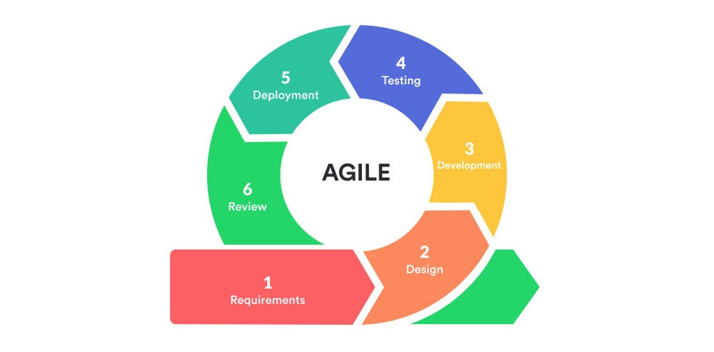

**Figure 3.1****: Agile Methodology (Jason, J, 2022).**

Advantages:

1. **Adaptability**: Agile accommodates changes in requirements, which is essential for an application aimed at meeting diverse user needs in a dynamic marketplace.
2. **Frequent Feedback**: Regular engagement with stakeholders ensure that the product corresponds with user expectations and market demands (Beck et al., 2001).
3. **Incremental Delivery**: Features can be released incrementally, allowing users to start benefiting from the application sooner rather than waiting for a full release.

While the Waterfall methodology is more traditional and linear—requiring completion of one phase before moving to the next—it may not be ideal for FindNearMe due to its rigidity. This methodology works best when project requirements are well-defined from the outset and unlikely to change (Royce, 1970). However, given the dynamic nature of local commerce applications and evolving user needs, this approach could lead to challenges if adjustments are needed after initial phases are completed.

**3.3 Methodology**

For the FindNearMe application, effective requirements gathering is critical to ensure that the final product aligns with user needs and stakeholder expectations. Based on research, two of the most effective methods for gathering requirements are Interviews and Observations.

**3.3.1 Interviews**

Interviews are an essential approach for getting in-depth information directly from stakeholders such as prospective customers (buyers and sellers), local company owners, and industry experts. This method allows one to ask specific questions about user needs, expectations, pain points, and desired features in a conversational manner, making it easier to gather qualitative data.

Interviews were conducted with consumers and vendors to understand their online shopping preferences. These interviews helped identify common needs and preferences, which informed the functional requirements of the system.

**3.3.2 Observations**

Observation is a valuable method for gathering requirements, particularly for applications like FindNearMe, where understanding user behavior and interactions with the system is crucial. This technique allows one to gain insights that may not be articulated during interviews or surveys.

Direct observations were carried out which revealed how consumers currently search for products in local shops, challenges faced by sellers in promoting their products and patterns in how users engage with local products vs. online marketplaces.

## 3.4 Tools and techniques

The frontend was built with Expo, a react native framework, with Tailwind CSS. In terms of backend and database, Supabase was used, an open-source backend-as-a-service platform created as an alternative to Firebase. It offers developers a PostgreSQL database, user authentication, real-time features, and file storage.

Supabase streamlines application development by automatically creating APls and providing a user-friendly interface, making it accessible to both experienced developers and individuals with less technical expertise. So, this handles user authentication and real-time communications in addition to the backend and database.

MobileNet, implemented in TensorFlow.js, is a state-of-the-art convolutional neural network developed by Google for image classification. This was utilized for the image search and matching functionality. For the mapping feature, OpenStreetMap’s API was used.

## 3.5 Ethical Consideration

When developing the FindNearMe mobile application, several ethical considerations were taken into account to ensure user trust, safety, and compliance with legal standards. Here are the key ethical considerations relevant to this application:

1. Given that FindNearMe will likely collect sensitive information such as location data and user profiles, it is essential to implement robust privacy measures to protect data.
2. Users should have control over their data and be able to manage permissions easily.
3. Given the disparities in internet access and digital literacy in Nigeria, the app should be designed to be as inclusive as possible, with considerations for users with limited internet access, older mobile devices, or lower digital literacy levels.
4. Since FindNearMe employs AI technologies for features like image recognition or personalized recommendations, ethical considerations surrounding AI must be addressed.
5. Ensuring that the app does not unfairly promote certain sellers or products over others is important. Algorithms should be transparent, and sellers should have equal opportunities to showcase their products.

## 3.6 Requirements Analysis

**3.6.1 Software Requirements**

1. Front-end: Expo-React Native, Tailwind CSS
2. Back-end: Supabase
3. Database: Supabase
4. Geolocation: OpenStreetMap
5. Operating System: Windows
6. Integrated Development Environment: VS code

**3.6.2 Hardware Requirements**

1. Mobile Phone: Android
2. A minimum of 4GB RAM
3. A stable internet connection

## 3.7 Requirements Specifications

**3.7.1 Functional Requirements Specifications**

**Table 3.1: Functional Requirements Specifications**

|  |  |
| --- | --- |
| **Req.**  **No.** | **Description** |
| FR1 | Users must be able to create an account using email or phone number |
| FR2 | Users must be able to create and edit their profiles and sellers must be able to manage their product listings. |
| FR3 | Users must be able to search for products using keywords, categories or image-based searches using AI-powered image recognition. |
| FR4 | Users must be able to view product details, including pricing and seller information. |
| FR5 | The app must provide users with location-based search results using GPS. |
| FR6 | Users must be able to communicate with sellers through in-app messaging. |
| FR7 | Users must be able to leave reviews and ratings for products and sellers. |
| FR8 | Admins must be able to manage user accounts and product listings. |

**3.7.2 Non-Functional Requirements Specifications**

**Table 3.2: Non-Functional Requirements Specifications**

|  |  |
| --- | --- |
| **Req.**  **No.** | **Description** |
| NFR1 | The application should load fast under normal network conditions. |
| NFR2 | Up to 1000 users should be able to access the system at once without experiencing any performance issues. |
| NFR3 | User data should be encrypted both in transit and at rest; complying with relevant data protection regulations. |
| NFR4 | The app should provide a seamless onboarding experience for new users. |
| NFR5 | The application should function correctly across various devices. |
| NFR6 | To make future modifications easier, code should be well-documented and modular. |

## 3.8 System Design

**3.8.1 Application Architecture**

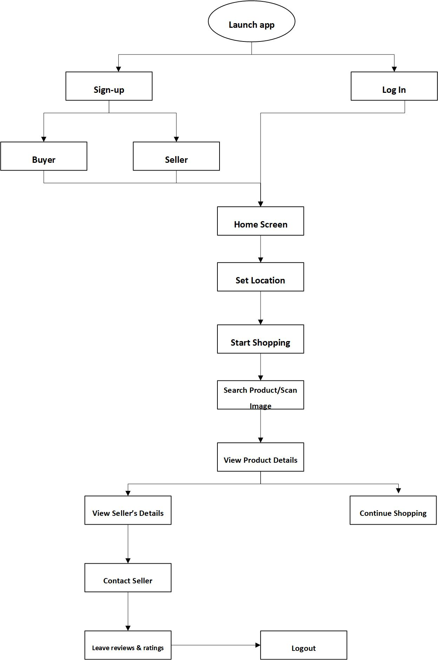

**Figure 3.2****: Application Diagram**

**3.8.2 Use Case Diagram**

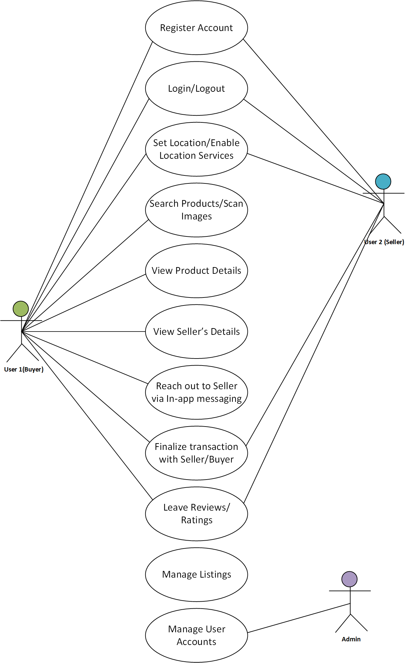

**Figure 3.3****: Use Case Diagram**

## 3.8.3 Use case description

**Table 3.3: Use case Description for Sign-Up/Log-In**

|  |  |  |
| --- | --- | --- |
| Use Case: | Sign-Up New User /Log-In | |
| Description | This use case describes the process by which users can create an account (sign-up) or log into the FindNearMe application. The system allows users to register with their email or phone numbers and subsequently log in to access personalized features. | |
| Actors: | User | |
| Preconditions: | 1. The user has access to the internet. 2. The user has a valid email address (for sign-up). 3. The user must not have previously registered with the same email (for sign-up). | |
| Postconditions: | 1. If the sign-up is successful, the user's details are stored in the database, and they are redirected to their profile page. 2. If the login is successful, the user is redirected to their dashboard. | |
| Main flow | User:   1. The use case begins when the user clicks the “Sign Up/Log-In” tab on the navigation bar. 2. The system displays the sign-up page, prompting the user to enter their username/email address, first name, last name, and password or log-in details. 3. The user fills in the required fields and clicks the “Sign Up/Log-In” button. | System:   1. The system verifies the given credentials. 2. If the verification is successful, the user is logged into the application. Otherwise, display an error message. 3. The system creates new user account and stores details in database. 4. Use case ends. |
| Exception  Condition: | If the login credentials are incorrect, an error message will appear. The user then has the option to retry entering correct credentials or cancel which will end the current process. | |

**Table 3.4: Use case Description for Search Products**

|  |  |  |
| --- | --- | --- |
| Use Case: | Search Products | |
| Description | This use case describes how users can search for products or services available in their vicinity using keywords, categories, or image upload. | |
| Actors: | User: Individuals looking to find products or services nearby. | |
| Preconditions: | 1. The user must be logged into their account. 2. The user’s location must be enabled on their device. | |
| Postconditions: | The system displays a list of products matching the search criteria. | |
| Main flow | User:   1. The use case begins when the user clicks the “Search” icon on the home screen. 2. The user inputs the search term/upload/scan image and submits the query. | System:   1. The system prompts the user to enter a keyword or select a category or upload/scan image. 2. The system retrieves product listings based on the user's location and search criteria. 3. The system displays the list of matching products, including images, prices, distance from user and seller information. |
| Exception  Condition: | **“No Results Found”** is triggered if no products match the search criteria. The system displays a message indicating no results were found and suggests alternative searches. | |

**Table 3.5: Use case Description for Product Details**

|  |  |  |
| --- | --- | --- |
| Use Case: | View Product Details | |
| Description | This use case allows users to view detailed information about a specific product, including images, descriptions, pricing, and seller information. | |
| Actors: | User: Individuals interested in learning more about a specific product. | |
| Preconditions: | The user must have performed a product search or accessed a product listing. | |
| Postconditions: | The user views detailed information about the selected product. | |
| Main flow | User:   1. The use case begins when the user selects a product from the search results. 2. A user can choose to add the product to their cart or contact the seller for more information. | System:   1. The system retrieves detailed information about the selected product from the database. 2. The system displays the product details page, including: Product images, Description, Price, Seller information, Availability status. |
| Exception  Condition: | **“Product Unavailable”** is triggered if the selected product is no longer available. The system displays a message indicating that the product is unavailable and suggests similar products. | |

**Table 3.6: Use case Description for Contact Seller via In-App Messaging**

|  |  |  |
| --- | --- | --- |
| Use Case: | Contact Seller via In-App Messaging | |
| Description | This use case describes the process by which users can communicate with sellers through an in-app messaging feature. This functionality allows buyers to ask questions, negotiate prices, and confirm details about products before making a purchase. | |
| Actors: | 1. User: Individuals interested in a product who wish to contact the seller. 2. Seller: Individuals or businesses listing products for sale. | |
| Preconditions: | 1. The user must be logged into their account. 2. The user must have viewed a product listing that they are interested in. | |
| Postconditions: | 1. The message is sent to the seller, and the user receives a confirmation of the sent message. 2. The seller can respond to the user’s inquiry through the same in-app messaging system. | |
| Main flow | User:   1. The use case begins when the user views a product detail page. 2. The user clicks on the "Contact Seller" button. 3. The user composes their message (e.g., asking about product availability or negotiating price) and clicks the “Send” button. 4. The seller receives a notification of the new message in their seller dashboard. | System:   1. The system displays a "Contact Seller" button on the product detail page. 2. The system opens an in-app messaging interface where the user can type their message. 3. The system validates that the message is not empty and sends it to the seller’s inbox. 4. The system displays a confirmation message indicating that the message has been sent successfully. |
| Exception  Condition: | **“Message Sending Error”** is triggered if there is an issue sending the message (e.g., network connectivity problems). The system displays an error message prompting the user to try again later. | |

**Table 3.7: Use case Description for Reviews/Ratings**

|  |  |  |
| --- | --- | --- |
| Use Case: | Leave Reviews/Ratings | |
| Description | This use case allows users to provide feedback on products they have purchased by leaving reviews and ratings for sellers and items. | |
| Actors: | User: Individuals who have completed a purchase and wish to leave feedback. | |
| Preconditions: | The user must have completed a purchase of a product from a seller. | |
| Postconditions: | The review and rating are stored in the database and associated with both the product and seller profiles. | |
| Main flow | User:   1. The use case begins when the user navigates to their liked list. 2. The user selects a product they wish to review. 3. The user submits their review. | System:   1. The system displays a list of purchased products eligible for review. 2. The system prompts the user to enter a rating (e.g., 1 to 5 stars) and write comments about their experience. 3. The system stores the review in the database and updates average ratings for both the product and seller profiles. |
| Exception  Condition: | **“Review Submission Error”** is triggered if there is an issue with submitting the review (e.g., network error). The system displays an error message prompting users to try again later. | |

**3.8.4 Activity Diagrams**

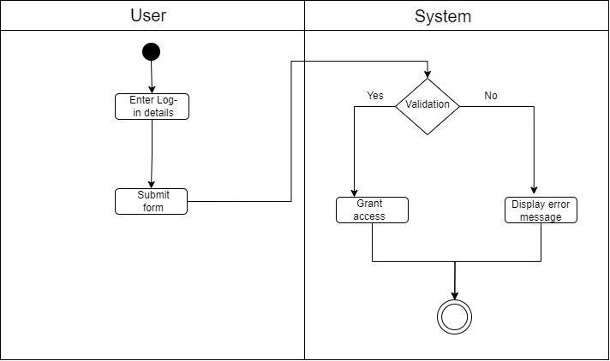

**Figure 3.4****: Activity Diagram for User Log-In**

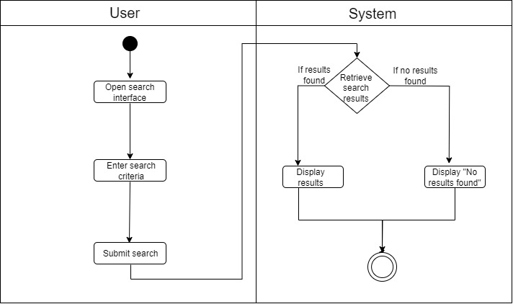

**Figure 3.5****: Activity Diagram for Product Search**

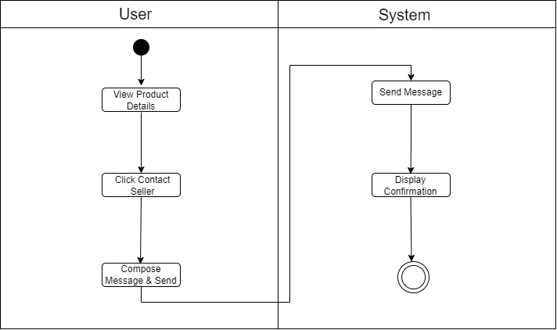

**Figure 3.6****: Activity diagram for Contact Seller**

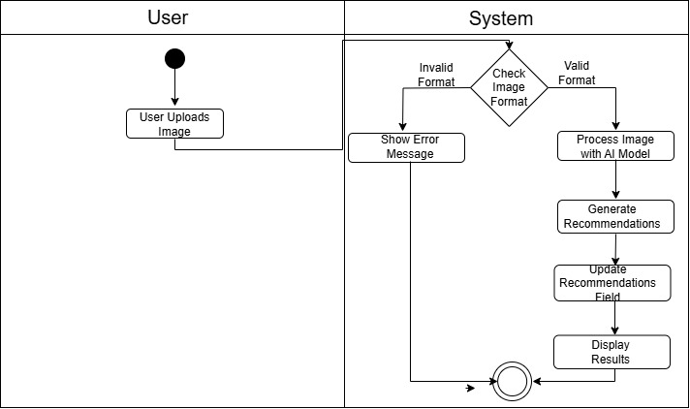

**Figure 3.7: Activity diagram for Image Upload**

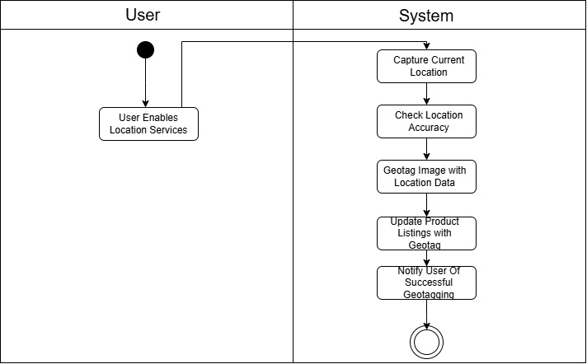

**Figure 3.8: Activity diagram for Geotagging**

**3.8.5 Dataflow Diagram**

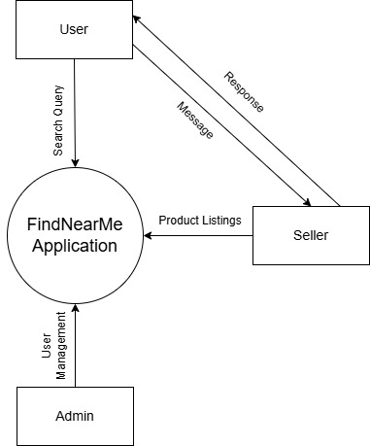

**Figure 3.9: DataFlow Diagram (Level 0)**

**3.8.6 Entity-Relationship Diagram (ERD)**

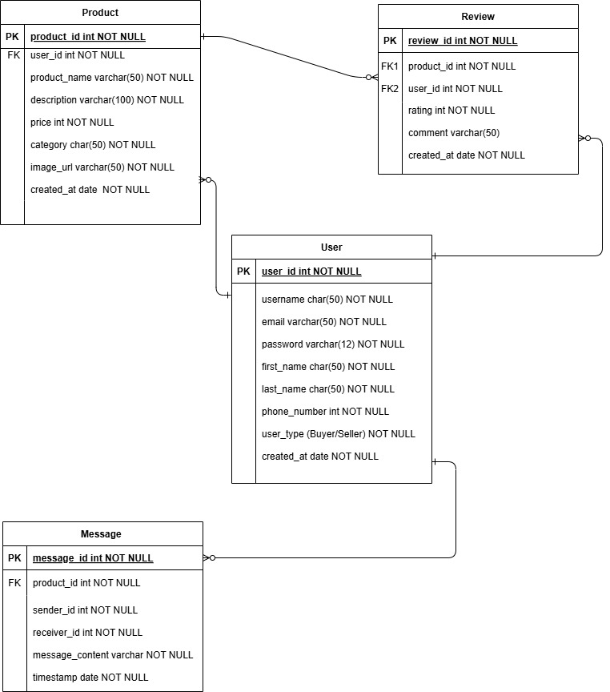

**Figure 3.10****: Entity Relationship Diagram**

* + 1. **User Interface Design**



**Figure 3.11: Onboarding Page**



**Figure 3.12: Home Page**

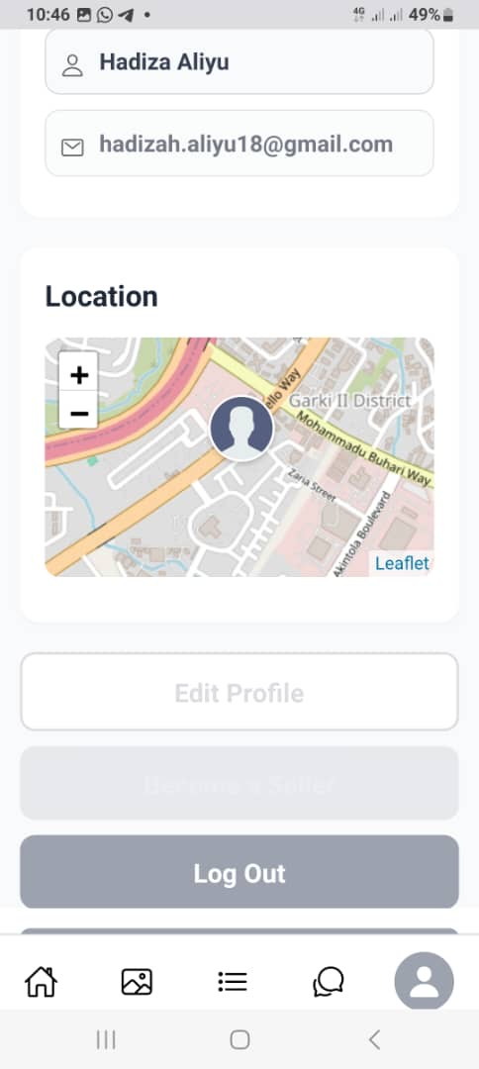

**Figure 3.13: User Profile Page**

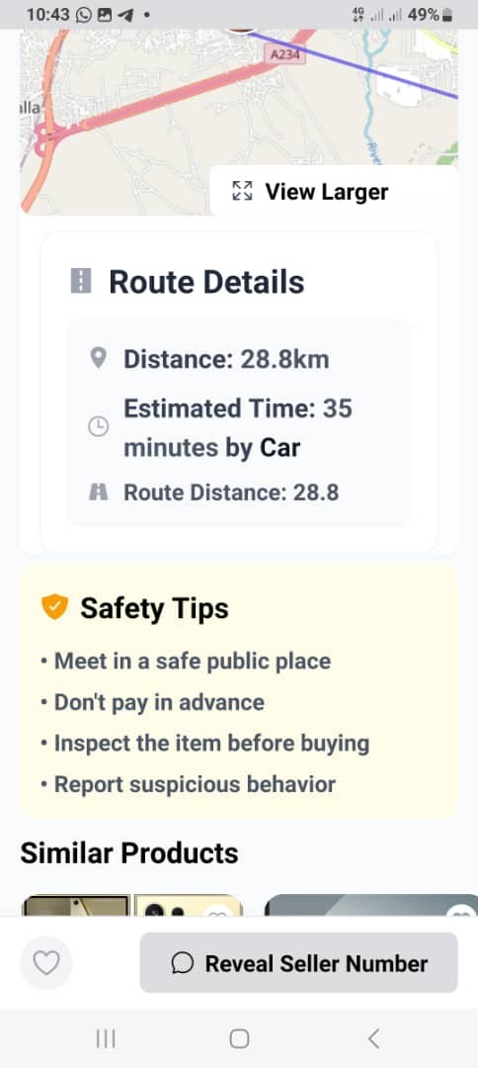

**Figure 3.14: Geolocation Page**

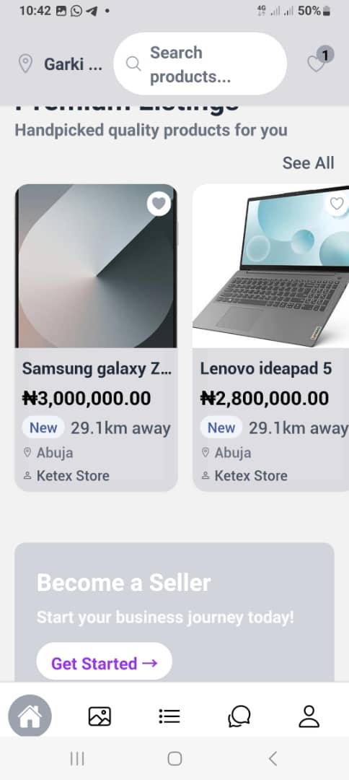

**Figure 3.15: Home Page II**

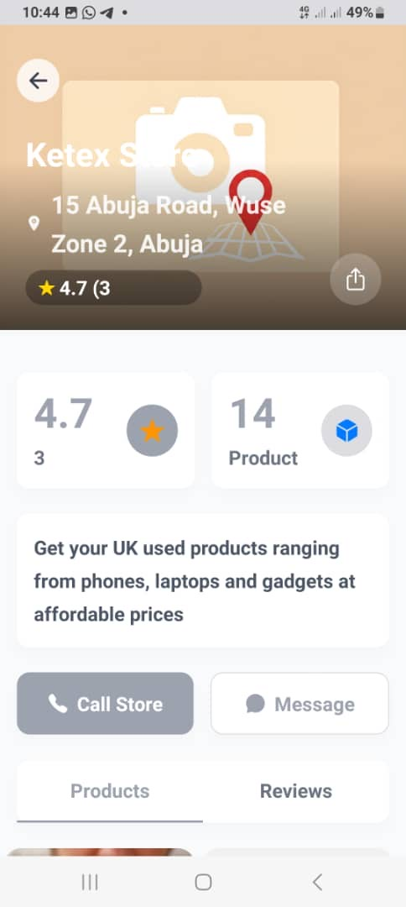

**Figure 3.16: Seller Profile Page**

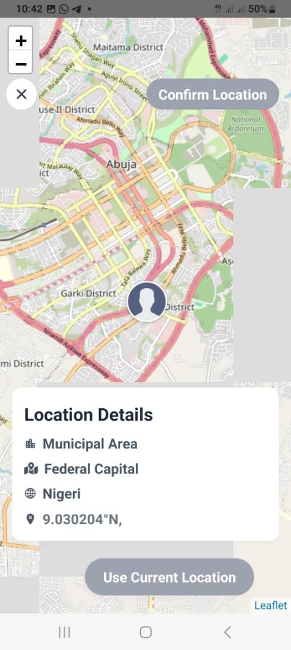

**Figure 3.17: User Map Page**

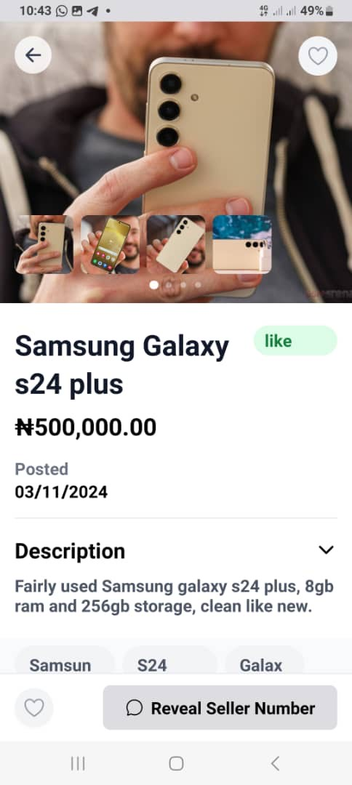

**Figure 3.18: Product Page**

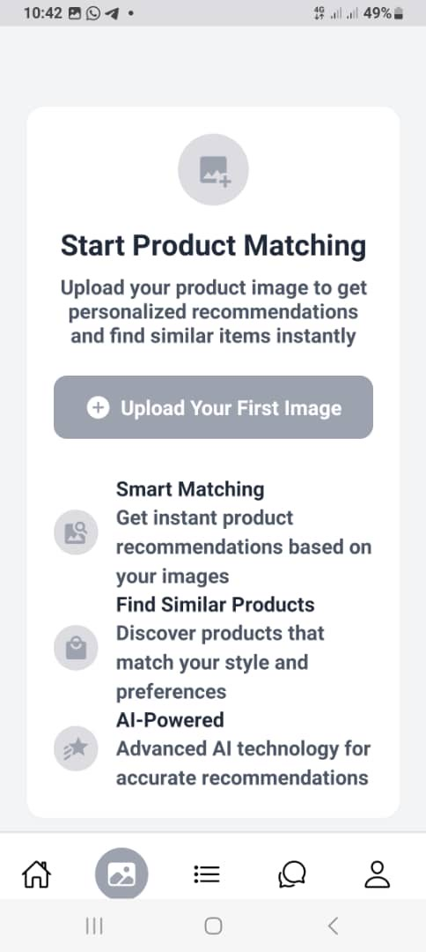

**Figure 3.19****: Image upload page**

**3.9 Summary**

This chapter outlines the project's development process, strategy, tools, and procedures. It discusses the ethical considerations and provides both functional and non-functional requirements. This is based on the requirements analysis and design used throughout project development. The system design for the application integrates various components to create a cohesive platform that facilitates local commerce. By employing structured architecture and clear data flow processes alongside well-defined entities and relationships, the design aims to deliver an efficient and user-friendly experience. This comprehensive approach ensures that all functional requirements are met while allowing for scalability and future enhancements.

# CHAPTER FOUR

# IMPLEMENTATION AND TESTING

## 4.1 Overview

This chapter describes the entire process involved in the implementation and testing of the FindNearMe mobile application. The chapter discusses the key characteristics of the program, the obstacles experienced during the implementation phase, and the solutions employed to overcome these concerns. Furthermore, it covers the testing techniques used to evaluate the program and verify its performance, reliability, and usefulness. Lastly, the chapter presents a usage guide for end-users and finishes with a summary of all significant elements.

## 4.2 Main Features

The **FindNearMe** application is designed to enhance the user experience by connecting local buyers and sellers through a variety of features. Below are the primary features that define the functionality of the app:

1. User Registration and Login
2. User Profile Management
3. Product Search Functionality: Users can search for products using image recognition, categories, or keywords.
4. Location-Based Services: Utilizes GPS to display nearby products based on the user's current location.
5. In-App Messaging
6. Product Listings Management
7. User Reviews and Ratings

## 4.3 Implementation Problems

During the development and implementation phase, several challenges arose such as:

1. Ensuring consistent performance across different devices required extensive testing and adjustments to UI elements.
2. Protecting user data against unauthorized access necessitated implementing robust security measures, including data encryption and secure authentication protocols.
3. During development, image imports were not functioning correctly, with the debugger showing that image paths were not being logged as expected. The issue originated from incorrect path alias configuration in tsconfig.json.
4. Integrating the MobileNet model from TensorFlow.js posed several compatibility issues within the Expo environment, including: performance problems leading to application errors, significant runtime delays affecting user experience and slow product creation due to real-time image analysis.

# **4.4 Overcoming Implementation Problems**

To address these challenges, the following solutions were employed:

* Responsive design principles were utilized to ensure that the application displayed correctly on various screen sizes and orientations.
* The application incorporated industry-standard security practices, such as OAuth2 for authentication and secure data transmission.
* To resolve the image import issues, instead of using relative paths like: **import** image **from** './assets/images/placeholder.jpg'; the correct implementation using the configured alias was: **import** placeholder **from** "@/assets/images/placeholder.jpg".
* The adopted solution for model compatibility involved implementing an asynchronous processing system using cron jobs, supported by a well-structured database schema. The cron job approach eliminates wait time during product creation, provides scalable processing based on application load, supports batch processing and operates independently from the main application flow.

## 4.5 Testing

A crucial step in guaranteeing the FindNearMe app's security, dependability, and performance was testing. The system was validated using both functional and non-functional testing approaches.

**4.5.1 Tests Plans**

**Table 4.1: Test Plan**

|  |  |
| --- | --- |
| **Test Plan ID** | TP-FNM-001 |
| **Test Plan Name** | FindNearMe Test Plan |
| **Version** | 1.0 |
| **Date** | 16/11/2024 |
| **Author** | Hadiza Aliyu |
| **Objective** | The primary objectives of this test plan are to:   * Verify that all features of the FindNearMe application function as intended. * Identify and resolve defects before the application is released to users. * Ensure that the application meets performance, security, and usability standards. |
| **Scope** | The scope of testing includes:   * Functional Testing * Usability Testing * Performance Testing * Security Testing * Compatibility Testing (across devices and operating systems) |
| **Test Strategy** | The testing strategy will encompass various types of testing to ensure comprehensive coverage:   * Functional Testing: Validate that all features work according to requirements. * Usability Testing: Assess user experience and interface design. * Performance Testing: Evaluate the application's responsiveness under load. * Security Testing: Identify vulnerabilities and ensure data protection. * Compatibility Testing: Test the application on different devices, screen sizes, and operating systems**.** |

**4.5.2 Test Cases**

**Table 4.2: Test Case for User Registration**

|  |  |
| --- | --- |
| **Test Case ID** | TC-FNM-001 |
| **Test Type** | Functional |
| **Description** | Verify that a new user can register successfully. |
| **Preconditions** | User is on the registration page. |
| **Steps** | 1. Enter valid username, email, and password. 2. Click "Sign Up." |
| **Expected Result** | User receives a confirmation message and is redirected to the profile page. |
| **Status** | Pass |

**Table 4.3: Test Case for Product Search**

|  |  |
| --- | --- |
| **Test Case ID** | TC-FNM-002 |
| **Test Type** | Functional |
| **Description** | Verify that users can search for products using keywords and image recognition. |
| **Preconditions** | User is logged in. |
| **Steps** | 1. Enter a keyword in the search bar/ Upload an Image. 2. Click "Search." |
| **Expected Result** | Relevant products are displayed based on the search query. |
| **Status** | Pass |

**Table 4.4: Test Case for In-App Messaging**

|  |  |
| --- | --- |
| **Test Case ID** | TC-FNM-003 |
| **Test Type** | Functional |
| **Description** | Verify that users can send messages to sellers. |
| **Preconditions** | User is viewing a product listing. |
| **Steps** | 1. Click "Contact Seller." 2. Compose a message and click "Send." |
| **Expected Result** | Message is sent successfully, and a confirmation is displayed. |
| **Status** | Pass |

**Table 4.5: Test Case for Navigation**

|  |  |
| --- | --- |
| **Test Case ID** | TC-FNM-004 |
| **Test Type** | Usability |
| **Description** | Verify that users can navigate through the app intuitively. |
| **Preconditions** | User is logged in. |
| **Steps** | 1. Access different sections (Home, Profile, Messages). |
| **Expected Result** | Users can navigate without confusion. |
| **Status** | Pass |

**Table 4.6: Test Case for Load Handling**

|  |  |
| --- | --- |
| **Test Case ID** | TC-FNM-005 |
| **Test Type** | Performance |
| **Description** | Verify that the application handles a high number of concurrent users. |
| **Preconditions** | Load testing environment set up. |
| **Steps** | 1. Simulate multiple users accessing the app simultaneously. |
| **Expected Result** | Application remains responsive without significant lag. |
| **Status** | Pass |

**Table 4.7: Test Case for Data Protection**

|  |  |
| --- | --- |
| **Test Case ID** | TC-FNM-006 |
| **Test Type** | Security |
| **Description** | Verify that user passwords are encrypted in the database. |
| **Preconditions** | User registration completed. |
| **Steps** | 1. Check database entries for user passwords. |
| **Expected Result** | Passwords should not be stored in plain text. |
| **Status** | Pass |

**4.5.3 Error Reports and Corrections**

This report outlines the identified errors during the testing phase of the FindNearMe application, along with their descriptions, severity levels, and proposed corrections. The goal is to provide a clear understanding of the issues and the steps needed to resolve them.

**Table 4.8: Error Reports and Corrections**

|  |  |  |  |
| --- | --- | --- | --- |
| Error ID | Description | Severity | Proposed Correction |
| ERR-001 | Product search returns no results for valid keywords. | High | Investigate search algorithm; ensure it queries the database correctly. |
| ERR-002 | In-app messaging experiences delays in message delivery. | Medium | Optimize WebSocket implementation for real-time messaging; check server load handling. |
| ERR-003 | User profile updates do not reflect immediately in the UI. | Low | Implement state management to refresh user data after updates. |
| ERR-004 | App crashes when accessing product details from search results on certain devices. | Critical | Investigate device-specific compatibility issues; perform debugging on affected devices. |

## 4.6 User Guide

The following is a brief guide for users on how to navigate and use the FindNearMe application:

1. Installation: Get the app from Google Play Store (Android).
2. Creating an Account: Open the app and tap **"Sign Up.",** fill in your details and tap **"Create Account,** verify your email via the link sent to you. Tap **"Login,"** enter your credentials, and access your account.
3. Navigating the App:
   1. Home Screen: Displays featured products and a search bar.
   2. Profile: Access your account settings and order history via the profile icon.
   3. Image Upload: Displays Image Upload section
   4. Location: Displays Map where you can set your location.
4. Searching for Products:
5. Tap the **Search Bar**.
6. Enter keywords or categories/ Upload an image of what you are looking.
7. Tap **"Search"** to view results.
8. Use filters to refine your search.
9. Viewing Product Details: Tap a product from search results to view images, descriptions, pricing, and seller info.
10. Contacting Sellers:
11. On the product page, tap **"Contact Seller."**
12. Compose your message and tap **"Send."**
13. Managing Your Profile: Access your profile to edit personal information, change your password, and view order history.
14. Leaving Reviews and Ratings:
15. Go to your order history.
16. Select an order, rate it (1-5 stars), and leave a comment.
17. Tap **"Submit Review."**

## 4.7 Summary

This chapter outlines the implementation and testing processes for the FindNearMe mobile application. It details key features such as user registration, product search, in-app messaging, and geotagging services. The implementation involved setting up the development environment, developing core functionalities, and integrating third-party services. Challenges included ensuring cross-platform compatibility and optimizing real-time messaging. Solutions involved responsive design techniques and using WebSocket protocols for efficient communication. Testing procedures included functional, usability, performance, security, and compatibility testing to ensure quality standards were met. A user guide was also provided to help users navigate the app effectively. In conclusion, this chapter emphasizes the significance of thorough implementation and testing in delivering a reliable, user-friendly application that meets expectations across platforms.

# CHAPTER FIVE

# SUMMARY, CONCLUSION AND RECOMMENDATION

## 5.1 Summary

This chapter provides a comprehensive discussion of the findings from the development and testing of the FindNearMe application. It evaluates the objectives set at the beginning of the project, assesses the limitations encountered, and outlines potential future enhancements. Additionally, recommendations for improving the application and its development process are presented, followed by a summary of key points.

**5.2 Objective Assessment**

The primary objective of the FindNearMe application was to create a user-friendly platform that facilitates local commerce by connecting buyers and nearby sellers effectively. Throughout the development process:

1. The application successfully incorporates features such as product search, in-app messaging, and user reviews, which enhance user engagement and interaction.
2. Implementation of asynchronous processing through cron jobs significantly improved performance, allowing for efficient product creation and image analysis without compromising user experience.
3. The architecture supports scalability, enabling the application to handle increased traffic and data as it grows.

Overall, the objectives were largely achieved, resulting in a functional and reliable application that meets user needs.

**5.3 Limitations and Challenges**

Despite the successes, several limitations and challenges were encountered during the development:

1. Technical Constraints: Issues with image imports and model compatibility highlighted challenges in integrating advanced AI capabilities within a mobile environment.
2. Resource Requirements: The initial exploration of TensorFlow Node.js revealed substantial resource requirements that could limit deployment on devices with less capacity.
3. User Feedback Integration: While usability testing provided valuable insights, incorporating all feedback into a single release cycle proved challenging due to time constraints.

**5.4 Future Enhancements**

To further improve the FindNearMe application, several enhancements can be considered:

1. Enhanced AI Capabilities: Future iterations could explore more advanced AI models for better image recognition and categorization, potentially improving user experience.
2. Offline Functionality: Implementing offline capabilities would allow users to access certain features without an internet connection, enhancing usability in areas with poor connectivity.
3. Payment Options: Integrating in-app payment methods would enhance convenience for users during transactions.
4. Online Inventory Management: An online inventory management system would allow sellers to track stock levels in real-time, manage product availability seamlessly, and automate notifications for low stock levels. This feature would enhance operational efficiency for sellers while providing buyers with accurate information about product availability.

**5.5 Recommendations**

1. Continuous User Feedback Loop
2. Regular Performance Testing

**5.6 Summary**

In conclusion, this chapter discussed the achievements of the FindNearMe application against its initial objectives while acknowledging limitations encountered during development. Future enhancements were proposed to ensure continued growth and improvement of the app. Finally, recommendations were made to support ongoing development efforts and optimize user experience. Overall, the project has laid a solid foundation for facilitating local commerce through innovative technology while highlighting areas for future exploration and enhancement.

# REFERENCES

Bao, J., Zheng, Y., Wilkie, D., & Mokbel, M. (2015). Recommendations in location-based social   
 networks: A survey. GeoInformatica, 19(3), 525-565.https://doi.org/10.1007/s10707-014-   
 0220-8

Beck, K., Beedle, M., van Bennekum, A., Cockburn, A., Cunningham, W., Fowler, M., … &

Jeffries, R. (2001). Manifesto for Agile Software Development.

Boyd, D. M., & Ellison, N. B. (2007). Social network sites: Definition, history, and scholarship.   
 Journal of Computer-Mediated Communication, 13(1), 210-230.   
 <https://doi.org/10.1111/j.1083-6101.2007.00393.x>

Buchholz, K. (2023). Global mobile e-commerce worth $2.2 trillion in 2023.   
 https://www.statista.com/chart/13139/estimated-worldwide-mobile-e-commerce-sales/

Coppola, D. (2024). E-commerce as percentage of total retail sales worldwide from 2021 to   
 2027. Retrieved from https://www.statista.com/statistics/534123/e-commerce-share-of-  
 retail-sales-worldwide/

Dhar, S., & Varshney, U. (2011). Challenges and business models for mobile location-based   
 services and advertising. Communications of the ACM, 54 (5), 121-128.   
 <https://doi.org/10.1145/1941487.1941515>

Educative.io. (2024). The complete guide to System Design in 2024.

El-Ebiary, Y., Al Moaid, Y., Hassan, A., Al-Kofahi, M., Alqudah, O., Liban, A., Al-Hodiany, Z.   
 M., & Hilles, S. (2022). E-commerce adoption: Problems facing SMEs in Nigeria.   
 International Journal of Special Education, 37(3).

eMarketer. (2021). Global e-commerce update 2021. Retrieved from   
 https://www.emarketer.com/content/global-ecommerce-update-2021

Geelan, J. (2009). Twenty-one experts define cloud computing. Cloud Computing Journal.

Gao, Y., Zhang, Y., & Wang, Y. (2019). The influence of mobile commerce on consumer   
 purchasing behavior: A study of Chinese consumers. Journal of Retailing and Consumer   
 Services, 50, 1-8. https://doi.org/10.1016/j.jretconser.2019.05.003

Hamari, J., Sjöklint, M., & Ukkonen, A. (2016). The sharing economy: Why people participate   
 in collaborative consumption. Journal of the Association for Information Science and   
 Technology, 67(9), 2047-2059. https://doi.org/10.1002/asi.23552

Heeks, R. (2008). ICT4D 2.0: The next phase of applying ICT for international development.   
 Computer, 41(6), 26-33.

Holzer, A., & Ondrus, J. (2011). Mobile application market: A developer's perspective.   
 Telematics and Informatics, 28(1), 22-31.

Huang, Z., & Benyoucef, M. (2017). User behavior in social commerce: A review of the   
 literature. International Journal of Information Management, 37(6), 634-640.   
 <https://doi.org/10.1016/j.ijinfomgt.2017.05.006>

HubSpot Blog. (2018). A Beginner's Guide to Data Flow Diagrams.

Jiang, Y., Chen, X., & Liu, Y. (2021). The impact of visual search on consumer behavior in e-  
 commerce. Journal of Retailing and Consumer Services, 60 ,102 -456.   
 doi: 10.1016/j.jretconser .2021 .102456

Johnson, M., & Lee, S. (2022). Enhancing user experience in e-commerce through AI-powered   
 image recognition. Computers in Human Behavior, 128 ,107 -115.

Kikulwe, E.M., Fischer, E., & Qaim, M. (2014). Mobile money, smallholder farmers, and   
 household welfare in Kenya. PloS One, 9(10), e109804.

Klein, J. (2018). The role of traditional markets in local economies: A historical   
 overview. Economic History Review, 71(3),745 -762.doi:10 .1111/ehr .12652

Kotha, S. (1998). Competing on the Internet: The case of Amazon.com. European Management   
 Journal, 16(2),212 -222.

Küpper, A. (2005). Location-based services: Fundamentals and operation. John Wiley & Sons.

Laudon, K.C., & Traver, C.G. (2017). E-commerce: Business, technology, society (13th ed.).   
 Pearson.

Laudon, K.C., & Traver, C.G. (2007). E-commerce (Vol29). Pearson/Addison Wesley.

Liu, Y., Zhang, Y., & Chen, Y. (2021). The impact of mobile technology on local commerce: A   
 geolocation perspective. Journal of Business Research, 124 ,205 -213.   
 doi:10 .1016/j.jbusres.2020 .11 .045

Masden, C. A., Grevet, C., Grinter, R. E., Gilbert, E., & Edwards, W.K. (2014). Tensions in   
 scaling-up community social media: a multi-neighborhood study of Nextdoor. Proceedings   
 of the SIGCHI Conference on Human Factors in Computing Systems, 3239 -3248.

Miers, D., & Hutton, G. (1996). The strategic challenges of electronic commerce. Electronic   
 Commerce, Enix Consulting Limited ,1 -19.

O’Brien, J.A. (2010). Introduction to information systems: Essentials for the internetworked e-  
 business enterprise (10th ed.). Boston: McGraw-Hill.

Reid, E. (2020). A look back at 15 years of mapping the world. Retrieved from   
 https://blog.google/products/maps/look-back-15-years-mapping-world/

Roig-Tierno, N., Baviera-Puig, A., Buitrago-Vera, J., & Mas-Verdu, F. (2013). The retail site   
 location decision process using GIS and the analytical hierarchy process. Applied   
 Geography, 40 ,191 -198.doi:10 .1016/j.apgeog .2013 .03 .005

Sachdev, P. (2024). How AI empowers image recognition and visual search in e-  
 commerce. Retrieved from https://inc42.com/resources/how-ai-empowers-image-  
 recognition-and-visual-search-in-ecommerce/

Schwaber, K., & Sutherland, J. (2017). The Scrum Guide.

Shankar, V., Kleijnen, M., Ramanathan, S., Rizley, R., Holland, S., & Morrissey, S. (2016).   
 Mobile shopper marketing:key issues, current insights, and future research avenues. Journal   
 of Interactive Marketing, 34 ,37 -48.doi:10 .1016/j.intmar .2016 .03 .002

Thompson, G. (2023). The role of local commerce in promoting environmental   
 sustainability. Sustainability, 15(2),123 -135.

West, J., & Mace, M. (2010). Browsing as the killer app: Explaining the rapid success of Apple's   
 iPhone. Telecommunications Policy, 34(5-6),270 -286.doi:10 .1016/j.telpol .2009 .12 .002

Xiao, B., & Benbasat, I. (2007). E-commerce product recommendation agents: Use,   
 characteristics, and impact. MIS Quarterly, 31(1),137 -209. Retrieved from   
 http://dl.acm.org/citation.cfm?id=2017335

Yue, X., Quan, C., Ma, C., Zhu, L., Chen, T., Kan, W., Pang, Y., & Liu, Y. (2019). A deep   
 learning approach for efficient large-scale mobile visual product search. Knowledge-Based   
 Systems, 163 ,588 -597.doi:10 .1016/j.knosys .2018 .09 .022

Zervas, G., Proserpio, D., & Byers, J.W. (2017). The rise of the sharing economy: Estimating the   
 impact of Airbnb on the hotel industry. Journal of Marketing Research, 54(5),687 -705.

Zhu, L., Yang, Y., Huang, Y., & Wang, W. (2017). A study on deep learning for e-commerce   
 image recognition. Proceedings of the 2017 International Conference on Deep Learning   
 Technologies, 6 -10. doi:10 .1145/3094243 .3094258

# APPENDICES

**Appendix A – Interview**

I conducted an informal interview with some of the stakeholders:

1. Are you a Buyer or Seller?
2. Do you have problems searching and obtaining goods locally?
3. Do you have problems finding customers for your goods?
4. Would you consider using an app to find products locally when in need?
5. What essential features do you believe are necessary for the FindNearMe application?
6. Are there any features from other similar applications that you think should be included in FindNearMe?
7. How would you describe your ideal user interface for the application?
8. What usability factors are most important to you when navigating an app like FindNearMe? For example, speed, simplicity, accessibility, etc.
9. What performance expectations do you have for the application?
10. How important is reliability in terms of uptime and error-free operations for your use of the app?
11. What concerns do you have regarding security and privacy while using the application? Are there specific security features that are essential for you?

**Appendix B – Source Codes**

